Name Date Period

Transpiration Lab

AP Biology

Introduction
www.phschool.com/science/biology_place/labbench/
The plant kingdom can be divided into two major groups: bryophyta (non-vascular) and tracheophyta (vascular). The major distinction between these two groups is the presence of specialized vascular tissue for the transport of water and food. While bryophytes, such as moss, lack conducting tissues, tracheophytes utilize specialized cells—xylem and phloem—for the transport of water and food. The evolution of vascular tissues and the subsequent ability to transport water and food over greater distances has contributed to the evolution of larger plants with specialized ground tissues and organs: roots for support and uptake of water and minerals, stems for support of leaves and flowers, and leaves for photosynthesis. These adaptations have allowed tracheophytes to become the dominant form of terrestrial plant.

Ground tissues, which comprise the pant body, or cortex, are made up of three types of cells: collenchyma, parenchyma, and sclerenchyma cells. Collenchyma cells are irregularly shapes, with thick cells wells. They are found in a plant stem, where they help support the body of a plant. Parenchyma cells are the photosynthetic cells of a plant, with thin, many-sided walls; they make up the ground tissue of a leaf. Sclerenchyma cells are elongated, with primary and secondary walls, containing lignin, a protein which strengthens the cell. Unlike parenchyma and collenchyma cells, they die at maturity. Sclerenchyma cells are often found near vascular tissue.

According to the generally accepted cohesion-tension theory, water is pulled up to the leaves of a plant by transpirational pull. When stomates are open, water transpires from higher water potential in the mesophyll spaces to lower water potential in the air. Decreasing water potential in the air spaces pulls water from nearby mesophyll cells, which in turn pull water from xylem vessels in nearby veins of the leaf.

Due to the cohesive nature of water molecules, when one water molecule is pulled from the xylem, more and more follow close behind in a chain of water molecules pulled upward from the roots to the leaves. The tension, or negative pressure, caused by the upward pull of the water column is so strong that the diameter of a stem actually decreases when the rate of transpirational pull is very high.

In the root, minerals actively absorbed from the soil increase the solute concentration of cortical cells. This causes water to flow by osmosis from the soil into the root, creating hydrostatic pressure known as root pressure. Water from the cortex of the root continually moves toward the xylem, aided by the push of root pressure, where it is then pulled up by transpiration. Root pressure and transpirational pull together provide more than enough force to offset the pull of gravity and raise water to the top of even the tallest redwood trees.

Although transpiration is the driving force behind water transport, plants have evolved many adaptations to prevent excessive loss of water by transpiration. As expected, the rate of transpiration varies directly with the amount of sunlight, heat, and wind in the environment, and a delicate balance must be maintained between stomates closing to prevent water loss and stomates opening for the exchange of oxygen and carbon dioxide. Guard cells regulate the stomates’ action, often closing them during the day when the rate of transpiration is high and opening them at night. In addition, the presence of wax (cutin) on the upper surface of leaves, or small hairs on the lower surface of leaves, prevents the loss of water. The rate of transpiration also varies indirectly with humidity in the environment. Cacti, which live in hot arid environments, have evolved small needle-like leaves to reduce the surface area from which transpiration can occur; whereas tropical plants in humid and shady environments can afford to have very large leaves.

Despite adaptations to limit the loss of water, plants lose as much as 90% of the water that enters their roots by transpiration from stomates. Factors which affect the rate of transpiration in plants and organization of a typical plant stem as it relates to the transport of water can easily be investigated.

Objectives
To explain how the concept of water potential relates to the transport of water from the roots to the stems and to the leaves of the plant, defining transpiration and relating this process to the overall transport of water in plants according to the cohesion-tension theory. Also to describe the properties of water as they relate to the transport of water in plants; quantitatively observe the effects of light intensity, wind, and humidity on the rate of transpiration of a common plant; and identify and describe the role of vascular and ground tissues in plants.
Procedure

Materials Needed

Bean Seedling
Potometer Setup (graduated pipet and tubing)
Syringe
Plastic Bag
parafilm
Spray Bottle
Ring Stand & clamps
Floodlight
Electric Fan

- Bend the tubing of the potometer into a U shape and clamp to a ring stand to hold the assembly upright. Use two clamps.
- With a syringe, fill the potometer with water.
- Cut the stem of a two-week-old bean seedling and place it into the open end of the tubing.
- Seal the opening with petroleum jelly. The seal must be airtight, or the seedling will not draw water.
- Let the potometer equilibrate for 10 minutes.
- Take a reading of the water level in the pipet (Setup 1) and record your results in Table 1 (Time 0). Take readings after 10, 20, and 30 minutes, and record your results in Table 1.
- Repeat the procedure with additional seedlings, in three different environments:
  - Mist the plant leaves with water and cover with a plastic bag; do not seal the bag (Setup 2)
  - Place a fan, on a low setting, approximately three feet from the plant (Setup 3)
  - Place the plant under a 100W floodlight (Setup 4)
- Once you have completed the experiment, cut off all the leaves and trace them on the cm grid to determine their total surface area.
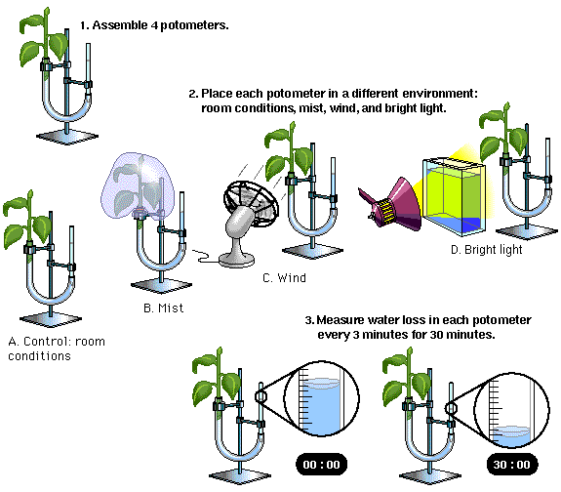

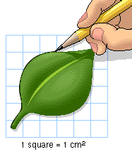

Images from:
www.phschool.com/science/biology_place/labbench/lab9/intro.html

Analysis My setup____________

Table 1
Data From Your Experiment
Cumulative Water Loss

 | Time
 | 0 min. | 10 min. | 20 min. | 30 min.

Initial reading (ml)
- reading at time “X” (ml)
= Cumulative water loss (ml)
÷ leaf area (m²)
= Cumulative water loss (ml/m²)

Use the cm grid below to trace the leaves AFTER the experiment… then determine the total area of your
leaves in m² : ________________ m² (note: 1 cm² = 0.0001m²)

Table 2
Class Data
Cumulative Water Loss in ml/m²

Setup | Time
 | 0 min. | 10 min. | 20 min. | 30 min.
1 (room)
2 (mist)
3 (fan)
4 (light)

Graph the class data for “Cumulative Water Loss” (four lines of best fit)

Questions
- What was the rate of water loss per minute in each of the plants in your experiment (hint: slope of the line)?

- How do each of the conditions of the plants affect the gradient of water potential from the stem to the leaves?

- How is the molecular structure of water significant to the transport of water in plants?

- What are the three adaptations that control the rate of transpiration in plants? Describe each one.

- In what ways are vascular plants better adapted to life on land as compared to bryophytes?

