Name Period

Cellular Respiration Lab
Respiration applies to two distinct but interrelated processes: the active acquisition of oxygen by an organism and the release of energy by the breakdown of organic compounds by metabolic chemical oxidation within cells. Various factors, such as temperature change, will affect respiration, as well as the chemical oxidation of glucose. Oxygen consumption during respiration can be measured, with a respirometer, as a change in gas volume.
P: pressure
V: volume
n: number of molecules
R: gas constant
T: temperature

A number of physical laws related to gases are important to the understanding of how the respirometer works. The laws are summarized in the general gas law of
PV = nRT.

This law summarizes the following important concepts about gases:
- Given a constant temperature and pressure, the volume of the gas is directly proportional to the number of molecules of the gas.
- Given a constant temperature and volume, the pressure of the gas changes in direct proportion to the number of molecules of gas present.
- Given a constant number of gas molecules and temperature, the pressure is inversely proportional to the volume.
- Given a change in temperature while the number of gas molecules remain constant, then either pressure or volume, or both, will change in direct proportion to the temperature.
- Gases and fluids flow from a high-pressure area to a low-pressure area.

Potassium hydroxide (KOH) can be used to remove the CO₂ produced during cellular respiration and form solid potassium carbonate (K₂CO₃) by the following reaction:

CO₂ + 2KOH → K₂CO₃ + H₂O

Therefore, the change in volume of gas in the respirometer will be directly related to the amount of oxygen consumed.

Objectives
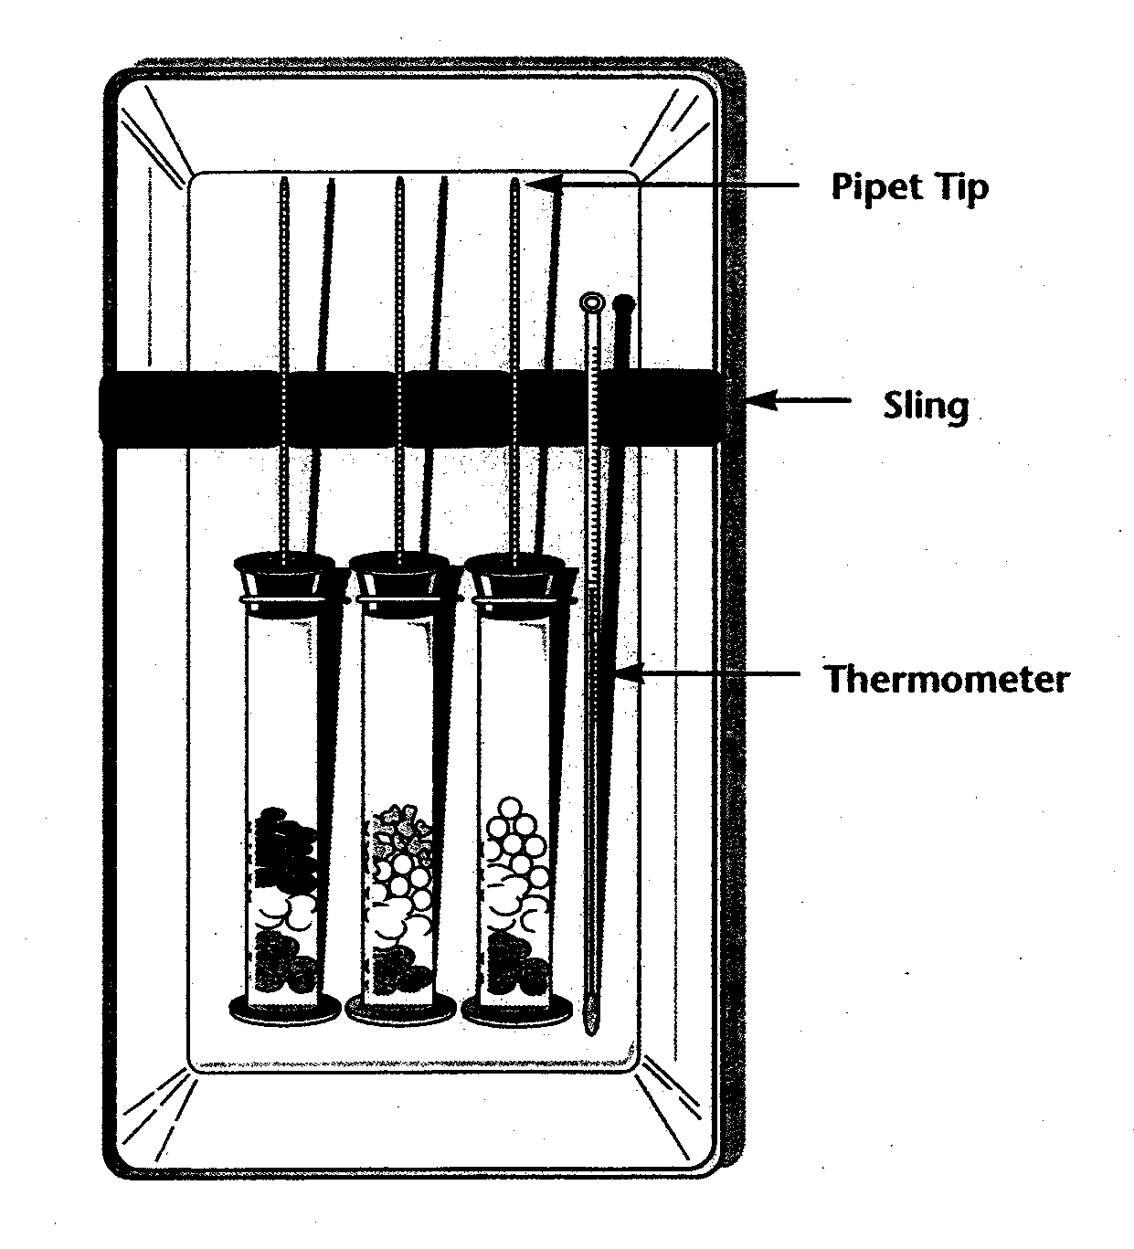
To demonstrate the relationship of gas laws to the function of a respirometer, the effect of germination or non-germination on cell respiration, and the relationship between dependent and independent variables. Also to explain the significance of a control, calculate the rate of cell respiration using derived data, and develop a hypothesis and design an experiment to measure cellular respiration using a respirometer.
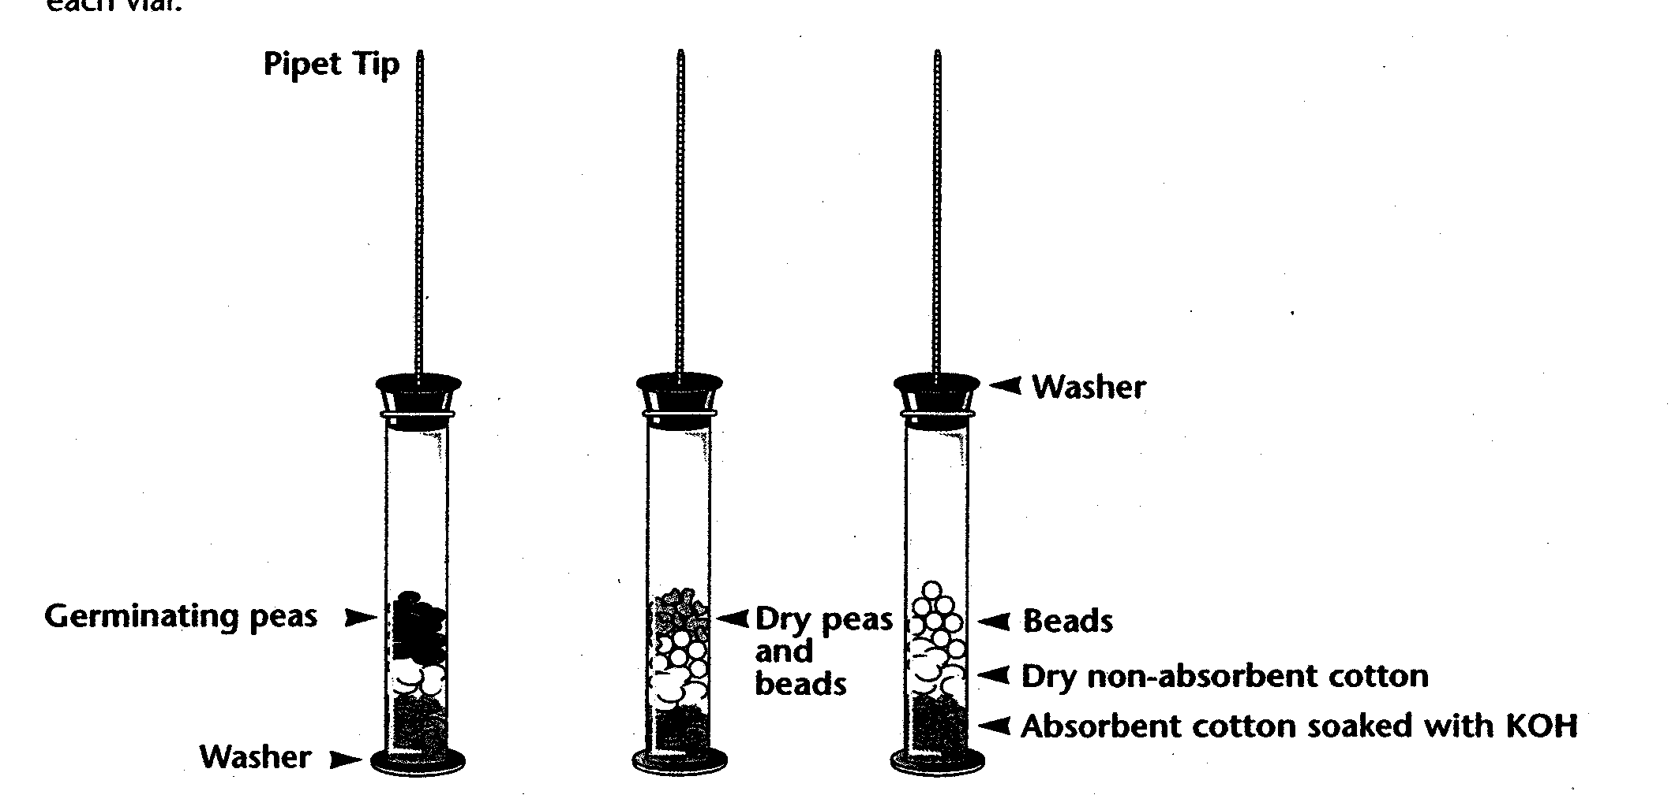
input.doc
Procedure

Materials Needed

10 Germinating Peas
10 Dry Peas
Glass Beads
Potassium Hydroxide
Waterbath
3 Respirometers (Glass Vials, Graduated Pipets, Stoppers)
1 Graduated Cylinder
3 Washers
Cotton & Rayon Balls
Forceps
Watch
Making Tape
Paper Towels

- Obtain three vials with steel washers on the bottoms.
- Fill a100ml graduated cylinder approx. half full with water. Add 8 germinating peas and take a reading of the displaced water. This is the volume of the germinating peas. Remove the peas and place them on a paper towel; set aside.
- Refill the graduated cylinder approx. half full with water. Add 8 dry non-germinating peas. Add glass beads until the volume is the same as that of the germinating peas. Remove the peas and beads and place them on a paper towel; set aside.
- Refill the graduated cylinder approx. half full with water. Add glass beads until the volume is the same as that of the germinating peas. Remove the beads and place them on a paper towel; set aside.

- Place a cotton ball in the bottom of each vial and add 1ml KOH into each cotton ball (being careful not to get any liquid on the sides of the vial). Place a non-absorbent rayon ball on the top of the KOH infused cotton ball.
Safety Note: Do not touch the KOH.
- Place the germinating peas, dry peas and beads, and beads in vials 1 through 3, respectively. Firmly insert a stopper assembly into each of the three vials. Place a second washer on the stopper end of each vial.
- Stretch a piece of masking tape across the upper edge of the waterbath to keep the pipets out of the water (see picture). Place vials 1 through 3 in the waterbath making sure the pipets rest on the strips of masking tape.
- After placing a drop of food coloring on the tip of the pipet (it makes it easier to read where the water is in the tube), fully immerse all three respirometers in the waterbath. Be sure that all respirometers are arranged so the pipets may be clearly read. Do not touch the respirometers once the experiment has started. Let the respirometers equilibrate for 5 minutes before making your “Time 0” reading.
Note: A small amount of water should enter the pipets when they are first immersed due to the cooling of the glass. If a pipet begins to fill with water, however, that respirometer has a leak, which should be repaired immediately.
- Read your respirometers to the nearest 0.001 ml and record the initial volumes as Time 0 in Table 1.
- Take additional readings every five minutes for 30 min. and record the volumes in Table 1.
Analysis
Table 1
Respiration
 |  | Germinating Peas |  |  | Dry Peas and Beads |  |  | Beads Only
Temp.  (°C) | Time  (min.) | Reading | Diff. | Corr.  Diff. | Reading | Diff. | Corr.  Diff. | Reading | Diff.
25 | 0 init.
25 | 5
25 | 10
25 | 15
25 | 20
25 | 25
25 | 30

- Calculate the corrected difference for each result. (This number factors out any changes due to factors other than consumption of oxygen by subtracting out the results of the beads alone.)

Difference = (initial reading time at 0) – (reading time at X)

Corrected Difference = (initial pea seed reading at time 0 – pea seed reading at time X) – (initial bead reading at time 0 – bead reading at time X)

- Graph your results from the corrected difference column for the germinating peas and dry peas. Plot the time in minutes on the X axis and the amount of oxygen consumed, in ml on the Y axis.

Questions
- What is the rate of oxygen consumed by germinating peas over time? (hint: slope)

- Why was it necessary to use glass beads in this experiment?

- Which of the two pea types, germinating or non-germinating, consumes the most oxygen? Why?

- During the aerobic respiration, glucose is broken down to form several end products. Which end products contain the carbon atoms from glucose?
The hydrogen atoms from glucose?
The oxygen atoms from glucose?
The energy stored in the glucose molecules?

- What is the substance that begins the series of reactions called the Krebs Cycle? Where does it come from?

- What substances are products of the Krebs Cycle; that is, which substances are produced which do not continue in the cycle?

- What is fermentation?

What are the two types of fermentation?

What organisms use fermentation?

- How are respiration and fermentation similar?

How are they different?

- Match the traits of each of the pathways:
a. Gycolysis
b. Krebs Cycle
c. Electron Transport System
- Carbon dioxide is given off ___
- Water is formed___
- PGAL___
- NADH becomes NAD+___
- Oxidative phosphorylation___
- Cytochrome carriers___
- Pyruvate___
- FAD becomes FADH2___

