INSECT COLLECTION ASSIGNMENT
We will discuss the rationale for doing an insect collection in class. You can see more on that topic at http://bughunter.tamu.edu/tenreasons/
The insect collection will consist of 40 properly pinned insects from 11 different Orders for partners. If you choose to work alone, you will need 30 insects from 11 different Orders. All insects must be collected locally – no exotic specimens! Due Date: ________________

Materials needed
Euthanizing - The best way to kill the insects is to put them in a sealed bag or container in the freezer for at least a day. Pin within a couple of days before they start drying out. Another option is to make a small glass jar "loaded" with ethyl acetate (often an ingredient in fingernail polish remover) absorbed on a cotton ball.
Pins - Insect pins are required (no push pins). These are long, thin, sharp, black pins, made especially for insect pinning. We have a fairly good supply of these available for recycling or you can purchase them at the Bohart Museum if you prefer (http://bohart.ucdavis.edu). No. 2 or 3 size is normal …smaller ones work well on small insects.
Net and Book - A net will be very helpful in catching many insects. They can be purchased … or make your own. See Figure 4 for plans for making your own net. Even simple, hobbled-together nets can be very effective. ID Books may be checked out of the library. We have some that we will use in class.
Box - A sturdy, covered box is necessary. We have some that you can borrow or the Bohart Museum at UCD has nice, inexpensive cardboard boxes if you prefer to purchase one.

Pinning and Labeling:
Do not take insects out of the freezer until you are prepared to pin them. (They will dry out in the freezer so don't leave them in there more than a week or two.) Most insects are pinned through the thorax a little to the right of center, but beetles should be pinned through the right wing. Generally, insert the pin through the insect until the insect is approximately 1.0cm (3/8") from the head of the pin. Pin the insect onto a piece of thick styrofoam until the insect rests near the styrofoam. With the aid of pins or tweezers move the legs and antennae to a natural position. The insect will dry just the way you arrange it, so do this quickly and carefully. Leave the insect in this position for a week (or more for larger insects) to allow for adequate drying. Large winged insects (moths, butterflies) should be pinned on a piece of foam with a groove cut into it to accommodate its body; fix the insect in place with enough pins and paper strips to keep them flat (see Fig 3). Once dry you can lift them off the styofoam and move them to your box. A video example of how to pin large winged insects can be found at www.youtube.com/watch?v=62pOS0mM-ww.
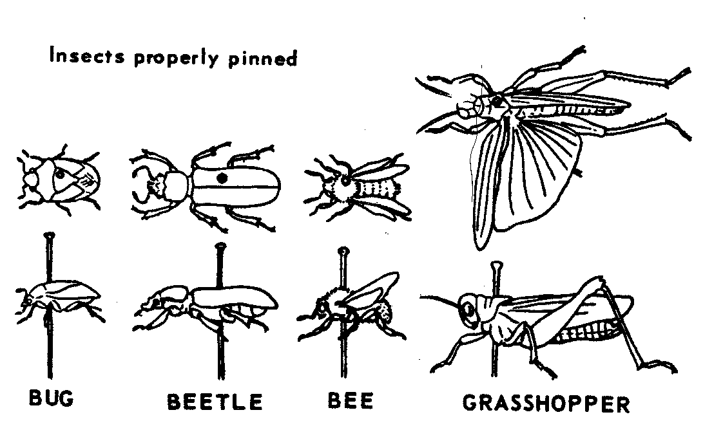
Fig. 1 Fig. 2 Fig. 3
Bug Beetle BeeGrasshopper

Insects properly pinned
*note location
1cm
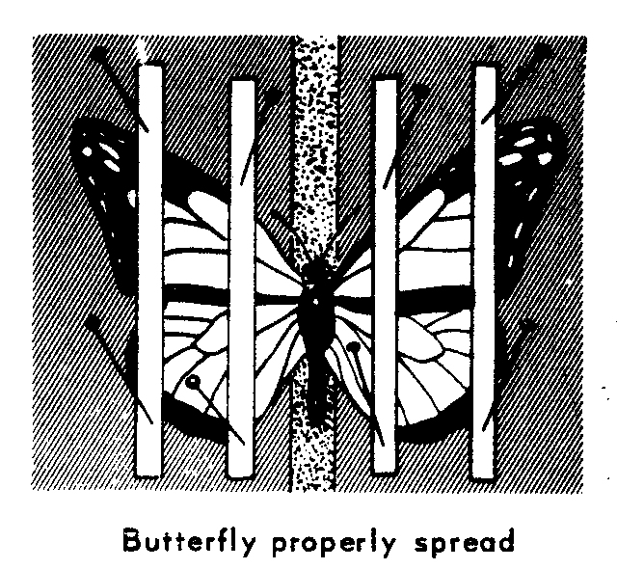
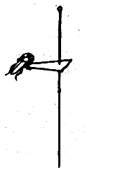
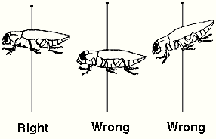

*Left wing extended only for grasshoppers and katydids
*Labels evenly and consistently spaced
Once they are dry, pinned specimens are to be labeled by a top and bottom tag which must include:
Top tag Bottom tag
-location of capture -Order
-date of capture -Common name
-name of collector
example:
Hymenoptera
Yellow Jacket
Yolo Co., Davis, CA
Sept 8, 2002
John Doe
Templates for making tags are available in downloadable format on School Loop.
- Labels look best if printed in small font size (6) on heavy paper. They should be no larger than 0.4” x 0.8” (or smaller), at a uniform height on the pin, and parallel with the insect. (see Fig. 1)
- The pin must be placed through the center on the labels at a uniform height under the pinned specimens with the labels in line with the body of the insect so the words can be read on the left side of the body.
- Insects that are too small to be pinned (less than 1/4" long) may be mounted with glue on a small paper point (see Fig. 2). The point (which should have this shape: ) should go to the left, with the head of the insect pointing straight ahead. The point should not extend beyond the midpoint of the insect's body.
- Soft-bodied insects that would shrivel when dried (e.g. silverfish, caterpillars, etc.) should be preserved in a vial of rubbing (isopropyl) alcohol with the back-to-back labels dropped inside the vial.
- Finally, display your collection (grouped and labeled by Order) in a box with styrofoam on the bottom.
Metal coat hanger for example

Grading:
Fig. 4
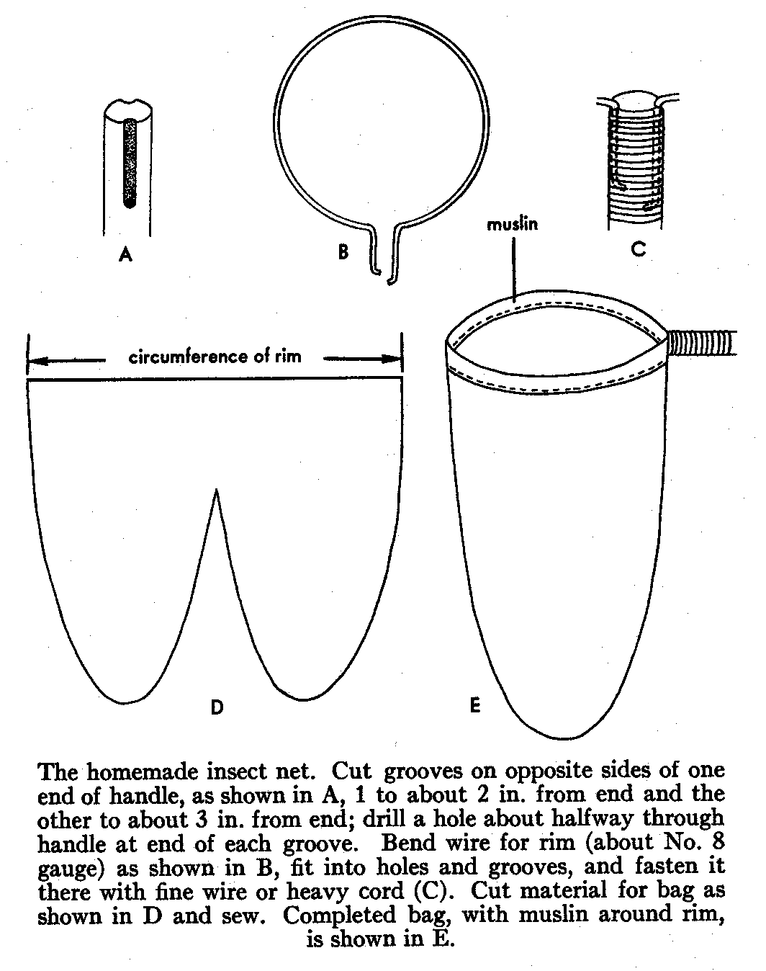
We are looking for quality not just quantity. The insect collection is a major part of your grade for the first quarter. The criteria used for grading include: completeness, proper identification, proper pinning/labeling technique, effort, organization and overall neatness. Major deductions will be taken for insects that are not completely dry.
You should be completely done collecting insects approximately three weeks before the due date to allow adequate time for the insects to dry. Be aware that it takes longer for some insects like mantids to dry. We will be giving you benchmarks as to how far you should be at different points in the project. No collections will be accepted after the due date, so send it with someone or turn it in early if you will be absent on the due date.
40 Insects : 20%
11 Orders: 22%
Technique: 40%
Identification: 10%
Neatness/Organization: 8%

Total Possible: 100%

Insect Collection FAQ
Can I use an insect that my little brother caught for me?
Yes. Remember that you must put the collector’s name on the label after you pin it. It is just like citing a source on an English paper; failure to do so is equivalent to plagiarism. Also, if your collection has a significant percentage of insects that were not collected by you, then your grade will reflect that. (Just like an English paper that was entirely quotations without any of your own ideas.)
Can I use an insect that I bought or that was collected somewhere else?
No. All of the insects must be collected and pinned by you (or collected by your family/friends on your behalf). You may not purchase any insects or use those you collected from some far off land on last summer’s vacation to Peru. When in doubt, ask the teacher ahead of time… don’t risk being blamed for unethical academic behavior.
Where is the best place to collect insects?
I recommend visiting the web site maintained by the Bohart Museum of Entomology (UC Davis) at http://bohart.ucdavis.edu/resources_howtocollect.aspx
Can I use insects from a previous year’s collection?
No. This is cheating. No insects may be used from previous students.
What do I do with an insect that is too small to pin?
Glue it onto the tip of a small paper triangle then pin the triangle.
What kind of glue do I use?
Any glue that dries clear; Elmer’s glue or clear nail polish work well.
Which way do the labels face?
They must be aligned with the body of the insect so that the words can be read on the left side of the insect’s body.
Do I have to spread the wings of small moths and butterflies?
Anything the size of a skipper or bigger (approx. the size of a dime) must have the wings spread properly (90-degree angle on the back edge of the front wings). You may keep the wings in a folded back position for smaller moths.
What kinds of insects should go into a vial with alcohol?
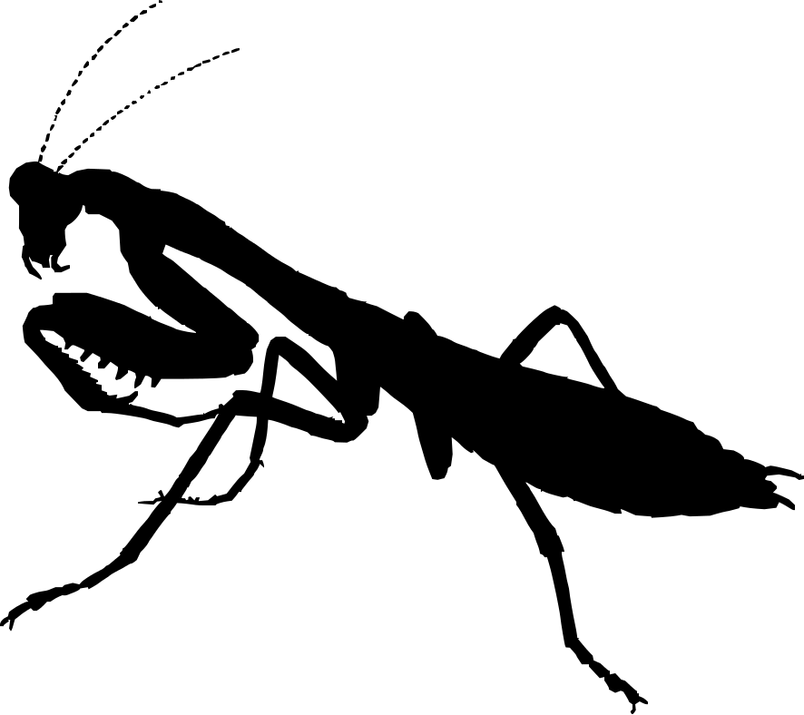
Generally, soft-bodied insects such as silverfish, aphids, termites, Jerusalem crickets, larvae of any kind, caterpillars, etc. You may also put problematic insects such as crane flies and mosquitoes into vials.
What kind of alcohol do I use in vials?
Rubbing (isopropyl) alcohol works well.
How do I pin a praying mantis?
Put the pin through the thorax at an angle with the head higher and the abdomen resting on the styrofoam. The front legs should be in the “praying position” under its thorax. The back two pairs of legs are treated like the other insects. Don’t spread a wing. There will be little room under the mantis for labels, so they will be closer together than other insects.
Insect Collection Labels Use Order labels like the ones below to organize your collection. These should be placed on the foam in the bottom of the box, with the members of each order pinned in rows below the labels going from the back of the box to the front.
Protura
Dermaptera
Neuroptera

Thysanura
Ephemeroptera
Collembola
Odonata
Orthoptera
Isoptera
Plecotera
Embioptera
Psocoptera
Zoraptera
Mallophaga
Anaplura
Thysanoptera
Hemiptera
Coleoptera

Mecoptera

Strepsiptera

Trichoptera

Lepidoptera

Diptera

Siphonaptera

Mantodea

Hymenoptera

Location and Name Labels:
Blattodea

Phasmatodea

Prepared, pinned specimens are to be identified by a top and bottom tag which must include:
Top tag Bottom tag
-location of capture -Order
-date of capture -Common name
-name of collector
example:
Hymenoptera
Yellow Jacket
Yolo Co., Davis, CA
Sept 8, 2008
John Doe
As previously mentioned the labels below are available online as a Word document for you to fill in as you collect. Copy and paste to make additional tags.
(Top Tag)
(Bottom Tag)
(Top Tag)
(Bottom Tag)
(Top Tag)
(Bottom Tag)

Yolo Co., Davis, CA
Sept 8, 2008
John Doe
Hymenoptera
Yellow Jacket
Yolo Co., Davis, CA
Sept 8, 2008
John Doe
Hymenoptera
Yellow Jacket
Yolo Co., Davis, CA
Sept 8, 2008
John Doe
Hymenoptera
Yellow Jacket

