Name Date Period
Molecular Biology Lab

To study the structure and function of a single protein-coding gene, one must prepare the gene in a purified form. Vertebrate cells contain enough DNA to code for more than I 00,000 proteins; therefore it is not very practical to isolate a gene by conventional biochemical procedures. This is why recombinant DNA technology is so important; it can be used to isolate and amplify a specific gene relatively simply.
Plasmids, small circular DNA molecules, are usually extra chromosomal; they exist apart from the chromosomes in most bacterial species. Plasmids are not necessary for the survival of the host bacteria, but they can contain genes that enable the bacteria to survive in certain environments. If a bacterial cell contains a plasmid carrying a gene that confers resistance to antibiotics, then that cell could survive in the presence of the drug.
Plasmids can be introduced into bacterial cells by the process of transformation. Bacteria placed in a calcium chloride solution can take in plasmid DNA molecules. In this way, large amounts of specific plasmid DNA can be prepared, because one transformed cell gives rise to duplicate cells also containing the plasmid DNA molecule. Plasmids are very important for the molecular biologist because they serve as gene- carrier molecules called cloning vectors. A gene of interest can be joined to vector DNA to form a hybrid or recombinant molecule that can replicate in bacteria. When preparing a recombinant DNA molecule, a procedure is required for cutting cloning vectors and cellular DNA molecules in precise positions.
Restriction endonucleases are important for recombinant DNA technology because they cut DNA at specific sites. These enzymes are usually made by bacterial species in which they degrade invading foreign DNA within the bacterial cell. Most restriction enzymes recognize a specific sequence of nucleotides in DNA and cut a long DNA double helix into restriction fragments, which are measured in the process of agarose gel electrophoresis.

Electrophoresis is the movement of charged particles in solution under the influence of an electric field. In gel electrophoresis, agarose gel is the stabilizing medium that serves as a matrix for the buffer in which the sample molecules travel. The gel is submerged in buffer within the electrophoretic gel cell. The samples are loaded into the sample wells in the gel, and electric current is passed through the gel.
Molecules of DNA are negatively charged because of negative charges on the phosphate group. In this exercise, nucleic acids migrate through the pores of the gel from the negative end of towards the positive end. The large DNA molecules move more slowly than smaller molecules, therefore molecules are sorted according to size.
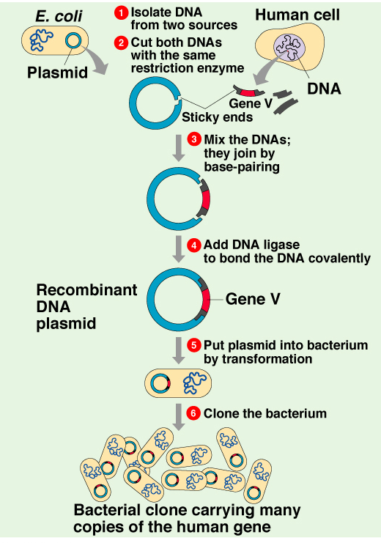

EXERCISE A: Bacterial Transformation – Ampicillin Resistance with pGRN gene

Background Information
You will insert a plasmid that contains a pGRN gene and a gene for resistance to ampicillin, an antibiotic that is lethal to many bacteria, into competent E. coli cells. Transformed bacteria can be selected based on their resistance to ampicillin by spreading the transformed cells on nutrient medium that contains ampicillin. Any cells that grow on this medium have been transformed.

Remember to eject all tips into the waste container and wear gloves!

- Transfer 200 μl of ice cold 0.05M CaCl₂ into your empty sample tube and put in the ice cup.

- Transfer a large (3mm) colony of E. coli from a starter plate to the tube using a sterile inoculating loop. Be careful not to transfer any agar.

- Vigorously tap the loop against the wall of the tube to dislodge the mass of cells.

- Mix the suspension by repeatedly drawing in and emptying a clean pipet tip.

- Using the P20 micropipette, add 5 μl of pGRN solution (0.005 μg/μl) directly into the cell suspension. Mix by flicking the tube with your finger. This solution contains a plasmid that has a gene for antibiotic (ampicillin) resistance as well as a gene for green fluorescent protein.

- Keep the tube on ice for 5-15 minutes.

- While the tube is on ice obtain an LB amp plate. Label it around the outer edge with your group name and ‘LB amp’ + pGRN
LABEL ON THE AGAR SIDE NOT THE LID

- Heat shock the cells by placing them directly from the ice to a water bath at 42ºC for 90 seconds.

- Immediately return the tube to ice for 2 minutes.

- Using a sterile micropipette (P200) tip add 100 μl of LB broth to the tube, mix by tapping gently.

- Place the 100 μl suspension onto the LB amp plate.

- Immediately spread the liquid throughout the dish using a sterile loop.

- Allow the plate to stand for a few minutes, turn upside down and incubate overnight at 37ºC.

- NOW WASH YOUR HANDS PLEASE
Lab A Analysis

1. Observe the colonies on the bottom of the plate. How many are there? _____________________

What color are they? _________________________________

2. How many colonies would you expect to see had you plated the bacteria onto an agar plate without

ampicilllin in it? _________, why? ____________________________________________________

3. If this experiment had been carried out with a control tube of bacteria that got water instead of

plasmid, how many colonies would you expect on the LB amp plate? ______, why? ____________

_______________________________________________________________________________

and on an LB no amp plate? ______, why? ___________________________________________

What color would the colonies be? __________________________

4. Transformation efficiency is expressed as the number of antibiotic-resistant colonies per microgram of
DNA (plasmid)

a. determine the total mass of pGRN used. _________________________________________

b. calculate the total volume of cell suspension prepared ______________________________

c. calculate the fraction of the total cell suspension that was spread on the plate. ___________

d. determine the mass of pGRN that was in the solution that was put on the plate._____________

e. determine the total number of colonies per microgram of plasmid. Express in scientific
notation ____________________________ (This is the transformation efficiency)

EXERCISE B: Restriction Enzyme Cleavage of DNA and Electrophoresis

Background Information
Restriction enzymes or restriction endonucleases are essential tools in recombinant DNA methodology. Several hundred have been isolated from a variety of prokaryotic organisms. Restriction endonucleases are named according to a specific system of nomenclature. The letters refer to the organism from which the enzyme was isolated. The first letter of the name stands for the genus name of the organism. The next two letters represent the second word or the species name. The fourth letter (if there is one) represents the strain of the organism. Roman numerals indicate whether the particular enzyme was the first isolated, the second, or so on.

Examples

EcoRI E = genus Escherichia
co = species coli
R = strain RY13
I = first endonuclease isolated

HaeII H = Haemophilus
ae = aegyptus
II = second endonuclease isolated

Restriction endonucleases recognize specific DNA sequences in double-stranded DNA (usually a four to six base-pair sequence of nucleotides) and digest the DNA at these sites. The result is the production of fragments of DNA of various lengths. Some restriction enzymes cut cleanly through the DNA helix at the same position on both strands to produce fragments with blunt ends (Figure 6.2a). Other endonucleases cleave each strand off-center at specific nucleotides to produce fragments with “overhangs” or sticky ends (Figure 6.2b). By using the same restriction enzyme to “cut” DNA from two different organisms, complementary “overhangs” or sticky ends will be produced and can allow the DNA from two sources to be “recombined.”

Figure 6.2a Figure 6.2b

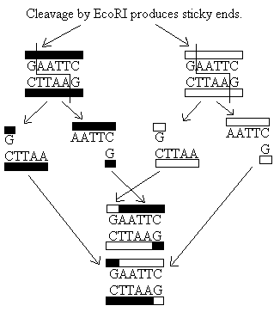
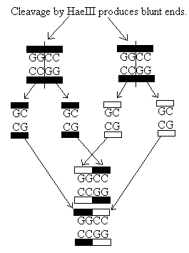
In this exercise, samples of DNA obtained from the bacteriophage lambda have been incubated with different restriction enzymes. The resulting fragments of DNA will be separated by using gel electrophoresis. One sample has been digested with the restriction endonuclease EcoRI, one with the restriction endonuclease HindIII, and the third sample is uncut. The DNA samples will be loaded into wells of an agarose gel and separated by the process of electrophoresis. After migration of the DNA through an electrical field, the gel will be stained with methylene blue, a dye that binds to DNA.
When any molecule enters an electrical field, the mobility or speed at which it will move is influenced by the charge of the molecule, the strength of the electrical field, the size and shape of the molecule, and the density of the medium (gel) through which it is migrating. When all molecules are positioned at a uniform starting site on a gel and the gel is placed in a chamber containing a buffer solution and electricity is applied, the molecules will migrate and appear as bands. Nucleic acids, like DNA and RNA, move because of the charged phosphate groups in the backbone of the DNA molecule. Because the phosphates are negatively charged at neutral pH, the DNA will migrate through the gel toward the positive electrode.
In this exercise, we will use an agarose gel. In agarose, the migration rate of linear fragments of DNA is inversely proportional to their size; the smaller the DNA molecule, the faster it migrates through the gel.

Procedure
1. Carefully place the pre-poured 1% agarose gel into the gel box.

2. Make sure that there is enough TAE buffer to cover the gel.

3. Carefully load 10 μl of the contents of each of the three tubes into separate wells.
- Phage lambda DNA digested with EcoRI endonuclease. The DNA is mixed with a gel-loading solution containing a tracking dye, bromophenol blue, that will make it possible to “track” the processes of it migration in the agarose gel.
- Phage lambda digested with HindIII endonuclease. The DNA fragments are of a known size and will serve as a “standard” for measuring the size of the EcoRI fragments from Step 2. It also contains the tracking dye.
- Undigested phage lambda DNA to use as a control. It also contains the tracking dye.
4. When both groups have loaded all three samples, place the lid on the box and electrophorese at
135 Volts for 20 minutes.

5. When the blue dye is about 3/4 of the way down the gel turn off the power and remove the gel.

6. Place the gel in the tupperware provided – this contains a blue solution that will stain the DNA in
your gel – DO NOT GET IT ON YOUR SKIN OR CLOTHES

7. Leave the gel in stain for 30 minutes or overnight.

8. Pour off the stain back into the bottle.

9. Wash the gel with warm water 2-3 times (this can go down the sink).

Analysis and Results

1. Examine your gel using the light box.

2. Label the wells and sketch the bands you see in the space provided. Compare your gel to the ideal
gel on the right.

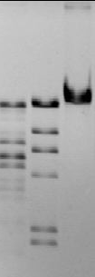
E H U

Background Information
The size of the fragments produced by a specific endonuclease (EcoRI in this exercise) can be determined by using standard fragments of known size (fragments produced by HindIII in this case). When you plot the data on semilog graph paper, the size of the fragments is expressed as the log of the number of base pairs they contain. This allows data to be plotted on a straight line. The migration distance of the unknown fragments, plotted on the x-axis, will allow their size to be determined on the standard curve.

Graphing

A: Standard Curve for HindIII

- Measure the migration distance (in cm) for each HindIII band on your gel (use the sample picture if you cannot see all of the bands in yours). Measure from the leading edge of the sample well to the leading edge of the band. The migration distance for the largest standard fragment (approximately 23,120 base-pairs) nearest to the origin does not need to be measured since it falls outside of our graph. Record these measurements in Table 6.1

- Plot the measured migration distance for each band of the standard HindIII digest against the actual base pair (bp) fragment sizes given in Table 6.1 using the semilog graph paper. Draw the best-fit line to your points. This will serve as a standard curve.

B: Interpolated Calculations for EcoRI
(*note: Interpolated means to estimate the value of a mathematical function that lies between known values, often by means of a graph)

From the standard curve for HindIII, made from known fragment sizes, you can calculate fragment sizes resulting from a digest with EcoRI. The procedure is as follows.

- Measure the migration distances in cm for each EcoRI band. Record the data in Table 6.2

- Determine the sizes of the fragments of phage lambda DNA digested with EcoRI. Locate on the x-axis the distance migrated by the first EcoRI fragment. Using a ruler, draw a vertical line from this point to its intersection with the best-fit data line. Now extend a horizontal line from the intersection point to the y-axis. This point gives the base-pair size of this EcoRI interpolated data in Table 6.2, in the interpolated bp column.

- Your teacher will provide you with the actual bp data.

Compare your results to these actual sizes. Note: This interpolation technique is not exact. You should expect as much as 10% to 15% error.

Table 6.1: Distance HindIII produced fragments migrate in agarose gel (cm)

HindIII
Actual bp | Measured Distance (cm)
23,130 | (Don’t measure…it doesn’t fit on graph)
9,416
6,557
4,361
2,322
2,027
570* | Can’t see
125* | Can’t see

* may not be detected
Table 6.2: Distance EcoRI produced fragments migrate in agarose gel (cm)

EcoRI
Band | Measured Distance (cm) | Interpolated bp | Actual bp
Band 1 | (Don’t measure) | --
Band 2
Band 3
One band
Band 4
Band 5
Band 6

- For which fragment sizes was your graph most accurate? For which fragment sizes was it least accurate?

Analysis

- Discuss how each of the following factors would affect the results of electrophoresis:
  - Voltage used

  - Running time

  - Amount of DNA used

  - Reversal of polarity

- Two small restriction fragments of nearly the same base-pair size appear as a single band, even when the sample is run to the very end of the gel. What could be done to resolve the fragments (i.e. separate them into two)? Why would it work?

Questions

- What is a plasmid? How are plasmids used in genetic engineering?

- What are restriction enzymes? How do they work? What are recognition sites?

- What is the source of restriction enzymes? What is their function in nature?

- Describe the function of electricity and the agarose gel in electrophoresis.

- If a restriction enzyme digest resulted in DNA fragments of the following sizes: 4,000 base pairs, 2,500 base pairs, 2,000 base pairs, 400 base pairs, sketch the resulting bands of electrophoresis. Show starting point, positive and negative electrodes, and the resulting bands.

- What are the functions of the loading dye in electrophoresis?

- Use the graph you prepared from your lab data to predict how far (in cm) a fragment of 8,000 bp would migrate.

